It’s so easy!

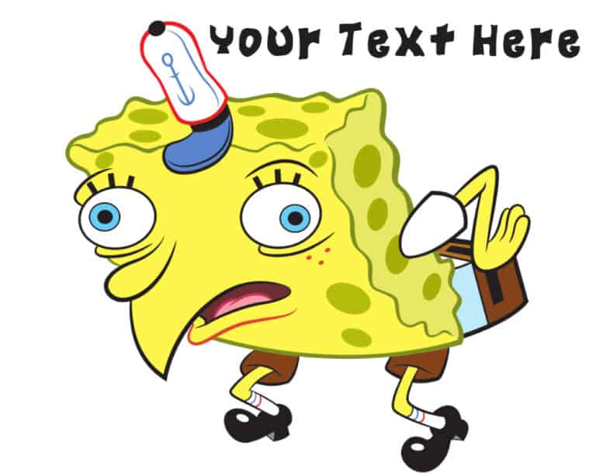

[This Photo](https://www.freemonogrammaker.com/spongebob-text-generator/) by Unknown Author is licensed under [CC BY-SA](https://creativecommons.org/licenses/by-sa/3.0/)